literature survey

1.1 Introduction
E-TESTING systems are being widely adopted in academic environments, as well as in combination with other assessment means, providing tutors with powerful tools to submit different types of tests in order to assess learners’ knowledge. Among these, multiple-choice tests are extremely popular, since they can be automatically corrected. However, many learners do not welcome this type of test, because often, it does not let them properly express their capacity, due to the characteristics of multiple-choice questions of being “closed-ended.” Even many examiners doubt about the real effectiveness of structured tests in assessing learners’ knowledge, and they wonder whether learners are more conditioned by the question type than by its actual difficulty.
1.1.1 Data Visualization
Data visualization is the graphical representation of information. Bar charts, scatter graphs, and maps are examples of simple data visualizations that have been used for decades. Information technology combines the principles of visualization with powerful applications and large data sets to create sophisticated images and animations. A tag cloud, for instance, uses text size to indicate the relative frequency of use of a set of terms. In many cases, the data that feed a tag cloud come from thousands of Web pages, representing perhaps millions of users. All of this information is contained in a simple image that you can understand quickly and easily.
Data visualization is the study of the visual representation of data, meaning "information which has been abstracted in some schematic form, including attributes or variables for the units of information".
According to Friedman (2008), the "main goal of data visualization is to communicate information clearly and effectively through graphical means. It doesn’t mean that data visualization needs to look boring to be functional or extremely sophisticated to look beautiful. To convey ideas effectively, both aesthetic form and functionality need to go hand in hand, providing insights into a rather sparse and complex data set by communicating its key-aspects in a more intuitive way. Yet designers often fail to achieve a balance between design and function, creating gorgeous data visualizations which fail to serve their main purpose is to communicate information".
Data visualization is closely related to Information graphics, Information visualization, Scientific visualization and Statistical graphics. In the new millennium data visualization has become active area of research, teaching and development. According to Post et al (2002), it has united the field of scientific and information visualization".
1.1.2 Data Acquisition
Data acquisition is the sampling of the real world to generate data that can be manipulated by a computer. Sometimes abbreviated DAQ or DAS, data acquisition typically involves acquisition of signals and waveforms and processing the signals to obtain desired information. The components of data acquisition systems include appropriate sensors that convert any measurement parameter to an electrical signal, which is acquired by data acquisition hardware.
1.1.3 Data Analysis
Data analysis is the process of looking at and summarizing data with the intent to extract useful information and develop conclusions. Data analysis is closely related to data mining, but data mining tends to focus on larger data sets, with less emphasis on making inference, and often uses data that was originally collected for a different purpose. In statistical applications, some people divide data analysis into descriptive statistics, exploratory data analysis and confirmatory data analysis, where the EDA focuses on discovering new features in the data, and CDA on confirming or falsifying existing hypotheses.
1.1.3.1 Types of data analysis are:
Exploratory data analysis (EDA): an approach to analyzing data for the purpose of formulating hypotheses worth testing, complementing the tools of conventional statistics for testing hypotheses. It was so named by John Tukey.
Qualitative data analysis (QDA) or qualitative research is the analysis of non-numerical data, for example words, photographs, observations, etc..
1.1.4 Data Governance
This is very useful information for DM Seminars. Data governance encompasses the people, processes and technology required to create a consistent, enterprise view of an organisation's data in order to:
- Increase consistency & confidence in decision making
- Decrease the risk of regulatory fines
- Improve data security
- Maximize the income generation potential of data
1.1.5 Data Management
Data management comprises all the academic disciplines related to managing data as a valuable resource. The official definition provided by DAMA is that "Data Resource Management is the development and execution of architectures, policies, practices and procedures that properly manage the full data lifecycle needs of an enterprise." This definition is fairly broad and encompasses a number of professions which may not have direct technical contact with lower-level aspects of data management, such as relational database management.
1.1.6 Data Mining
Data mining is the process of sorting through large amounts of data and picking out relevant information. It is usually used by business intelligence organizations, and financial analysts, but is increasingly being used in the sciences to extract information from the enormous data sets generated by modern experimental and observational methods.
It has been described as "the nontrivial extraction of implicit, previously unknown, and potentially useful information from data and the science of extracting useful information from large data sets or databases." In relation to enterprise resource planning, according to Monk (2006), data mining is "the statistical and logical analysis of large sets of transaction data, looking for patterns that can aid decision making".
Data mining is the process of extracting patterns from data. Data mining is seen as an increasingly important tool by modern business to transform data into an informational advantage. It is currently used in a wide range of profiling practices, such as marketing, surveillance, fraud detection, and scientific discovery.
The related terms data dredging, data fishing and data snooping refer to the use of data mining techniques to sample portions of the larger population data set that are (or may be) too small for reliable statistical inferences to be made about the validity of any patterns discovered (see also data-snooping bias). These techniques can however, be used in the creation of new hypothesis to test against the larger data populations.
1.1.7 Knowledge Discovery
Knowledge discovery is a concept of the field of computer science that describes the process of automatically searching large volumes of data for patterns that can be considered knowledge about the data. It is often described as deriving knowledge from the input data.
This complex topic can be categorized according to 1) what kind of data is searched; and 2) in what form is the result of the search represented.
The most well-known branch of data mining is knowledge discovery, also known as knowledge discovery in databases (KDD). Just as many other forms of knowledge discovery it creates abstractions of the input data. The knowledge obtained through the process may become additional data that can be used for further usage and discovery
1.1.8 Distance Learning
Distance education, or distance learning, is a field of education that focuses on the pedagogy, technology, and instructional system designs that aim to deliver education to students who are not physically "on site" in a traditional classroom or campus. It has been described as "a process to create and provide access to learning when the source of information and the learners are separated by time and distance, or both." In other words, distance learning is the process of creating an educational experience of equal quality for the learner to best suit their needs outside the classroom. Distance education courses that require a physical on-site presence for any reason (including taking examinations) is considered a hybrid or blended course of study. This emerging technology is becoming widely used in universities and institutions around the globe. With the recent trend of technological advance, distance learning is becoming more recognized for its potential in providing individualized attention and communication with students internationally. The most widely cited] pedagogical theory of distance education is that of "transactional distance".

1.1.9 Visual Data Mining
One popular definition of Knowledge Discovery in Databases is the non-trivial process of identifying valid, novel, potentially useful, and understandable patterns in data. Data mining which can be seen as the core of the KDD process actually maps the data to some kind of valid, novel, potentially useful and understandable knowledge. Obviously, just the user can determine whether the resulting knowledge satisfies these requirements. Moreover, the usefulness of some kind of knowledge varies from user to user. The new area of visual data mining focuses on integrating the user in the KDD process in terms of effective and efficient visualization techniques, interaction capabilities and knowledge transfer.
The manual extraction of patterns from data has occurred for centuries. Early methods of identifying patterns in data include Bayes' theorem (1700s) and regression analysis (1800s). The proliferation, ubiquity and increasing power of computer technology has increased data collection and storage. As data sets have grown in size and complexity, direct hands-on data analysis has increasingly been augmented with indirect, automatic data processing. This has been aided by other discoveries in computer science, such as neural networks, clustering, genetic algorithms (1950s), decision trees (1960s) and support vector machines (1980s). Data mining is the process of applying these methods to data with the intention of uncovering hidden patterns. It has been used for many years by businesses, scientists and governments to sift through volumes of data such as airline passenger trip records, census data and supermarket scanner data to produce market research reports. (Note, however, that reporting is not always considered to be data mining.)
A primary reason for using data mining is to assist in the analysis of collections of observations of behavior. Such data are vulnerable to collinearity because of unknown interrelations. An unavoidable fact of data mining is that the (sub-)set(s) of data being analyzed may not be representative of the whole domain, and therefore may not contain examples of certain critical relationships and behaviors that exist across other parts of the domain. To address this sort of issue, the analysis may be augmented using experiment-based and other approaches, such as Choice Modelling for human-generated data. In these situations, inherent correlations can be either controlled for, or removed altogether, during the construction of the experimental design.
There have been some efforts to define standards for data mining, for example the 1999 European Cross Industry Standard Process for Data Mining (CRISP-DM 1.0) and the 2004 Java Data Mining standard (JDM 1.0). These are evolving standards; later versions of these standards are under development. Independent of these standardization efforts, freely available open-source software systems like the R Project, Weka, KNIME, RapidMiner and others have become an informal standard for defining data-mining processes. Notably, all these systems are able to import and export models in PMML (Predictive Model Markup Language) which provides a standard way to represent data mining models so that these can be shared between different statistical applications. PMML is an XML-based language developed by the Data Mining Group (DMG), an independent group composed of many data mining companies. PMML version 4.0 was released in June 2009.

ANALYSIS

2.1 Introduction
E-Testing systems are being widely adopted in academic environments, as well as in combination with other assessment means, providing tutors with powerful tools to submit different types of tests in order to assess learners’ knowledge. Among these, multiple-choice tests are extremely popular, since they can be automatically corrected. However, many learners do not welcome this type of test, because often, it does not let them properly express their capacity, due to the characteristics of multiple-choice questions of being “closed-ended.” Even many examiners doubt about the real effectiveness of structured tests in assessing learners’ knowledge, and they wonder whether learners are more conditioned by the question type than by its actual difficulty.
In order to teach learners how to improve their performances on structured tests, in the past, several experiments have been carried out. It would be an extremely valuable achievement, since it would let tutors exploit many currently available data exploration and knowledge discovery (KDD) strategies to elicit important insights on the testing activities that can be used to teach learners how to improve their performances.
The main goal of this project is about the system to let tutors monitor several important aspects related to online tests, such as test quality. This project includes the logging of important data related to learner interaction with the system during the execution of online tests and exploits data visualization to highlight information useful to let tutors review and improve the whole assessment process.
In particular, by analyzing the data visualization charts, we have detected several previously unknown test strategies used by the learner.
Finally, we also present a system implementing the proposed approach. The system logs all the interactions of learners with the e-testing system interface. In particular, it captures the occurrence of question browsing and answering events by the learners and uses these data to visualize charts containing a chronological review of tests.
The system is Web based and relies on the Struts, Hibernate technology in order to capture all of the learners’ interactions with the e-testing system interface (running in the Web browser). The system is composed of a logging framework that can be instantiated in any e-testing systems and a stand-alone application that analyzes the logs in order to extract information from them and to graphically represent it.

The objective of this Project is to find the relationships among time and test items. In particular, by analyzing the data visualization charts, I have detected several previously unknown test strategies used by the learners.
2.2 Existing System
e-Testing systems are being widely adopted in academic environments, as well as in combination with other assessment means, providing tutors with powerful tools to submit different types of tests in order to assess learners’ knowledge. Among these, multiple-choice tests are extremely popular, since they can be automatically corrected. However, many learners do not welcome this type of test, because often, it does not let them properly express their capacity, due to the characteristics of multiple-choice questions of being “closed-ended.” Even many examiners doubt about the real effectiveness of structured tests in assessing learners’ knowledge, and they wonder whether learners are more conditioned by the question type than by its actual difficulty.
2.2.1 Limitations
1) Textual or verbal communication of information which opposes data visualization.
2) No monitoring of text results to asses the knowledge of the student clearly.
2.3 Proposed System
The proposed system to let tutors monitor several important aspects related to online tests,such as test quality. This project includes the logging of important data related to learner interaction with the system during the execution of online tests and exploits data visualization to highlight information useful to let tutors review and improve the whole assessment process.
In particular, by analyzing the data visualization charts, we have detected several previously unknown test strategies used by the learners.
2.3.1 Advantages
1) To discover knowledge related to learner activities during online tests which can be used by tutors to produce new text strategies.
2) Monitoring the online tests by means of data visualization.
3) Data visualization provides a graphical representation of data, documents and structures which turns out to be useful for various evaluation purposes.

Software Requirement Specification

for

Monitoring Online Tests through Data Visualization

Version: 1.0 approved
Prepared by: Harikrishna Pydi
CVSR College of Engineering

Table of Contents
2.4.1 Introduction 12
2.4.1.1Purpose 12
2.4.1.2Document Conventions 12
2.4.1.3Intended Audience and Reading Suggestions 12
2.4.1.4Project Scope 12
2.4.1.5References 12

2.4.2 Overall Description 13
2.4.2.1Product Perspective 13
2.4.2.2User Classes and Characteristics 13
2.4.2.3Operating Environment 13
2.4.2.4Design and Implementation Constraints 13
2.4.2.5User Documentation 13

2.4.3 System features 13

2.4.4 External Interface Requirements 14

2.4.4.1User Interfaces 14
2.4.4.2Hardware Interfaces 14
2.4.4.3Software Interfaces 14
2.4.4.4Communications Interfaces 15

2.4.5 Other Nonfunctional Requirements 15
2.4.5.1Security Requirements 15

Appendix A: Glossary 15

2.4 Software Requirement Specification
2.4.1 Introduction
2.4.1.1 Purpose:
The purpose of this system to let tutors monitor several important aspects related to online tests, such as test quality. This project includes the logging of important data related to learner interaction with the system during the execution of online tests and exploits data visualization to highlight information useful to let tutors review and improve the whole assessment process.
2.4.1.2 Document Convention:
Bond paper should be used for the preparation of the Thesis. Typing should be done on the 12 point size letters for the running text, 14 point size for the sub-headings and 16 point size for main headings /titles/names/etc. The font should be preferably TIMES NEW ROMAN.
2.4.1.3 Intended Audience and Reading suggestion:
This system is developed to implement online tests for different technical languages such as Java, .NET etc., and exploits data visualization to highlight information useful to let tutors review and improve the whole assessment process.
2.4.1.4 Scope:
This project is used to write online tests for different subjects and also to monitor the test results by means of Data Visualization in the form of graphs. This project is developed in Java under Windows platform, which has different and efficient properties like Swings, Struts, Hibernate etc., which provide look and feel effect of the application and provides data visualization through graphs.
2.4.1.5 References:
1. www.java.sun.com
2. www.java2s.com/Tutorial/MySQL
3. www.google.com
4. www.w3schools.com
5. Programming Jakarta Struts - O'Reilly Media
6. Handbook of Data Visualization

2.4.2 Overall Description
2.4.2.1 Product perspective:
This system includes online tests framing for different technologies and the test results exploits data visualization to highlight information useful to let tutors review and improve the whole assessment process.
2.4.2.2 User class and Characteristics:
This can be used by students and teachers, it does require background knowledge and technical knowledge of Java, .NET etc., and accessing the internet, who wants to write online tests. It provides monitoring of online tests through data visualization.
2.4.2.3 Operating environment:
Hardware specifications:
Processor : INTEL P4 PENTIUM 1.8 Ghz
Size of RAM : 1 GB RAM
Size of hard disk : 80 GB HD
Software specifications:
Operating System : Windows XP
Languages : Struts, Hibernate in Java
Development Kit : JDK 1.6.0
Database : My SQL
2.4.2.4 Design and Implementation constraints:
The constraint used in the system is online tests framing and monitoring the online tests through data visualization.
2.4.2.5 User Documentation:
- www.java.sun.com
- www.wikipedia.com
- www.java2s.com
- The Unified Modeling Language User Guide: By Grady Booch
- Software Engineering: By Sommerville
2.4.3. System Features:
- Register the name for writing/monitoring online tests with the following fields:
- Username
- Password
- Email
2. Login in to the system with the following fields:
- Username
- Password
Input:
Username: raju Password: raju
Output:
Accept the username and opens the home page of online tests.
3. Validation:
- The fields Username and Password we have entered to login were verified with the same fields as in the database.
- Username and password fields should not be kept empty.
4. Students chooses the online test he wants to write.
5. Students write the online tests by answering the multiple choice questions by clicking their desired option.
- Admin monitors the test results written by students through Data Visualization through graphs.
2.4.4 External Interface Requirements:
2.4.4.1 User Interface:
The user interface of this system is a user friendly Java Graphical User Interface.
2.4.4.2 Hardware Interfaces:
The interaction between the user and the console is achieved through Java capabilities.
2.4.4.3 Software Interfaces:
The required software is Java with Struts and Hibernate.

2.4.4.4 Communication Interfaces:
The system could be connected to intranet and internet and various communicating devices.
2.4.5 Other Non-Functional Requirements:
The data must be in the form of characters and numbers .
2.4.5.1 Security Requirements:
The code is implemented in the JAVA language. In this system we are provides validation criteria using user id and password.
Appendix A: Glossary
KDD - Knowledge Discovery in Databases
SWT - Standard Widget Toolkit
AJAX - Asynchronous JavaScript and XML
HTML- Hyper Text Markup Language

DESIGN

3.1 INTRODUCTION
Designing is the first step in the development phase for any techniques and principles for the purpose of defining a device, a process or system in sufficient detail to permit its physical realization.
Once the software requirements have been analyzed and specified the software design involves three technical activities design, coding, generation and testing that are required to build and verify the software. The design activities are of main importance in this phase, because in this activity, decisions ultimately affecting the success of the software implementation and its ease of maintenance are made. These decisions have the final bearing upon reliability and maintainability of the system. Design is the only way to accurately transfer the customer requirements into finished software or a system.
3.2 Unified Modeling Language
The design phase of project is implemented using Unified Modeling Language (UML). UML was introduced in 1997, has rapidly been accepted throughout the software industry as the standard graphical language for specifying, constructing, visualizing, and documenting software-intensive systems. The UML provides anyone involved in the production, deployment, and maintenance of software with a standard notation for expressing a system's blueprint. The UML covers conceptual things, such as business processes and system functions, as well as concrete things, such as programming-language classes, database schemas, and reusable software components.
The UML is a graphical language for specifying visualizing constructing and documenting the artifacts of software systems
Building Blocks of the UML
The vocabulary of the UML encompasses three kinds of building blocks:
- Things
- Relationships
- Diagrams

UML Things

Structural Things
Graphical notations used in structural things are the most widely used in UML. These are considered as the nouns of UML models. Following are the list of structural things.
- Classes
- Interface
- Collaboration
- Use case
- Active classes
- Components
- Nodes

Class Notation
UML class is represented by the diagram shown below. The diagram is divided into four parts.
- The top section is used to name the class.
- The second one is used to show the attributes of the class.
- The third section is used to describe the operations performed by the class.
- The fourth section is optional to show any additional components.
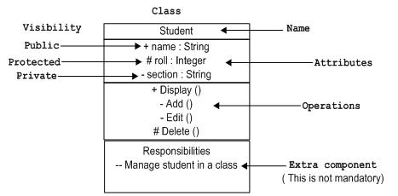
Classes are used to represent objects. Objects can be anything having properties and responsibility.

Collaboration Notation
Collaboration is represented by a dotted eclipse as shown below. It has a name written inside the eclipse.
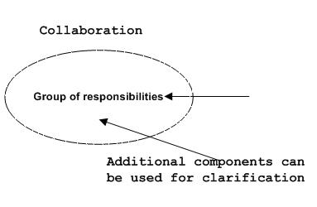
Collaboration represents responsibilities. Generally responsibilities are in a group.
Use case Notation
Use case is represented as an eclipse with a name inside it. It may contain additional responsibilities.
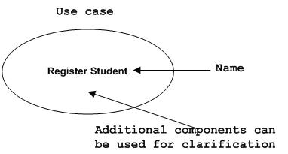
Use case is used to capture high level functionalities of a system.

Actor Notation:
An actor can be defined as some internal or external entity that interacts with the system.
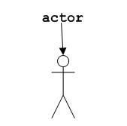
Actor is used in a use case diagram to describe the internal or external entities.

Component Notation
A component in UML is shown as below with a name inside. Additional elements can be added wherever required.
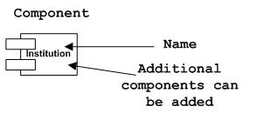
Component is used to represent any part of a system for which UML diagrams are made.

Node Notation

A node in UML is represented by a square box as shown below with a name. A node represents a physical component of the system.
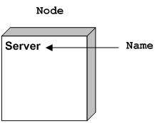
Node is used to represent physical part of a system like server, network etc.
Behavioral Things
Dynamic parts are one of the most important elements in UML. UML has a set of powerful features to represent the dynamic part of software and non software systems. These features include interactions and state machines.
Interactions can be of two types:
- Sequential (Represented by sequence diagram)
- Collaborative (Represented by collaboration diagram)

Interaction Notation
Interaction is basically message exchange between two UML components. The following diagram represents different notations used in an interaction.
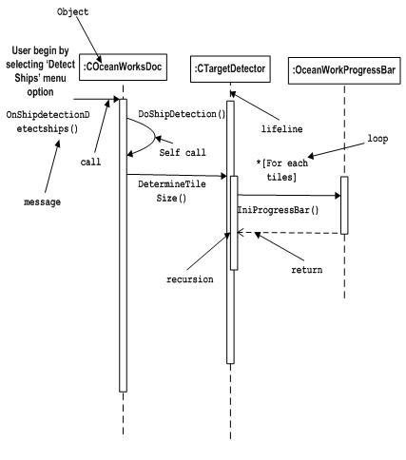
Interaction is used to represent communication among the components of a system.

State machine Notation
State machine describes the different states of a component in its life cycle. The notations are described in the following diagram.
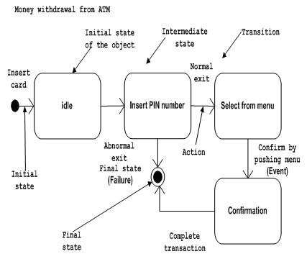

3.2.2 Relationships
Relationships between classes are generally represented in class diagrams by a line or an arrow joining the two classes. UML can represent the following, different types of object relationships.

Association
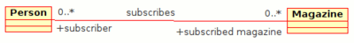

Class diagram example of association between two classes
An Association represents a family of links. Binary associations (with two ends) are normally represented as a line, with each end connected to a class box. Higher order associations can be drawn with more than two ends. In such cases, the ends are connected to a central diamond.
An association can be named, and the ends of an association can be adorned with role names, ownership indicators, multiplicity, visibility, and other properties. There are five different types of association. Bi-directional and uni-directional associations are the most common ones. For instance, a flight class is associated with a plane class bi-directionally. Associations can only be shown on class diagrams. Association represents the static relationship shared among the objects of two classes. Example: "department offers courses", is an association relation.

Aggregation
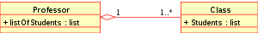

Class diagram showing Aggregation between two classes
Aggregation is a variant of the "has a" or association relationship; aggregation is more specific than association. It is an association that represents a part-whole or part-of relationship.
In UML, it is graphically represented as a hollow diamond shape on the containing class end of the tree of lines that connect contained class(es) to the containing class.

Composition
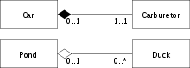
Class diagram showing Composition between two classes at top and Aggregation between two classes at bottom
Composition is a stronger variant of the "owns a" or association relationship; composition is more specific than aggregation. It is represented with a solid diamond shape.
The UML graphical representation of a composition relationship is a filled diamond shape on the containing class end of the tree of lines that connect contained class to the containing class.

Class Level Relationships

Generalization
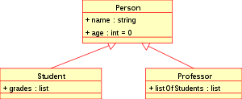

Class diagram showing generalization between one super class and two subclasses
The Generalization relationship indicates that one of the two related classes (the subtype) is considered to be a specialized form of the other (the super type) and super type is considered as 'Generalization' of subtype. The UML graphical representation of a Generalization is a hollow triangle shape on the super type end of the line (or tree of lines) that connects it to one or more subtypes.
The generalization relationship is also known as the inheritance or "is a" relationship.
The supertype in the generalization relationship is also known as the "parent", super class, base class, or base type.
The subtype in the specialization relationship is also known as the "child", subclass, derived class, derived type, inheriting class, or inheriting type.

UML DIAGRAMS
3.3.1 Class Diagram
A Class diagram shows a set of classes, interfaces, and collaborations and their relationships. Class diagrams are the most common diagram found in modeling object-oriented systems.
3.3.2 Use case Diagram
A Use case diagram shows a set of use cases and actors and their relationships. Use case diagrams are especially important in organizing and modeling the behaviors of a system.
3.3.3 Sequence Diagram
A Sequence diagram is an interaction diagram that emphasizes the time ordering of message. A Sequence diagram shows a set of objects and the messages sent and received by those objects.
3.3.4 Collaboration Diagram
A Collaboration diagram is an interaction diagram that emphasizes the structural organization of the objects that send and receive messages. A collaboration diagram shows a set of objects, links among those.
3.3.5 Activity Diagram
An Activity diagram shows the flow from activity to activity within a system. An activity shows a set of activities, the sequential or branching flow activity to activity, and object that act and are acted upon. Activity diagrams are especially important in modeling the function of a system. Activity diagrams emphasize the flow of control among objects.
3.3.6 State chart Diagram
A State chart Diagram displays the sequences of states that an object of an interaction goes through during its life in response to received stimuli, together with its responses and actions.
3.3.7 Component Diagram
A Component Diagram displays the high level packaged structure of the code itself. Dependencies among components.

3.3.8 Deployment Diagram
A Deployment Diagram displays the configuration of run-time processing elements and the software components, processes, and objects that live on them. Software component instances represent run-time manifestations of code units.
3.3.9 Object Diagram
An object diagram in the Unified Modeling Language (UML), is a diagram that shows a complete or partial view of the structure of a modeled system at a specific time.

3.4 UML Diagrams in the project
3.4.1 Main Use -case Diagram

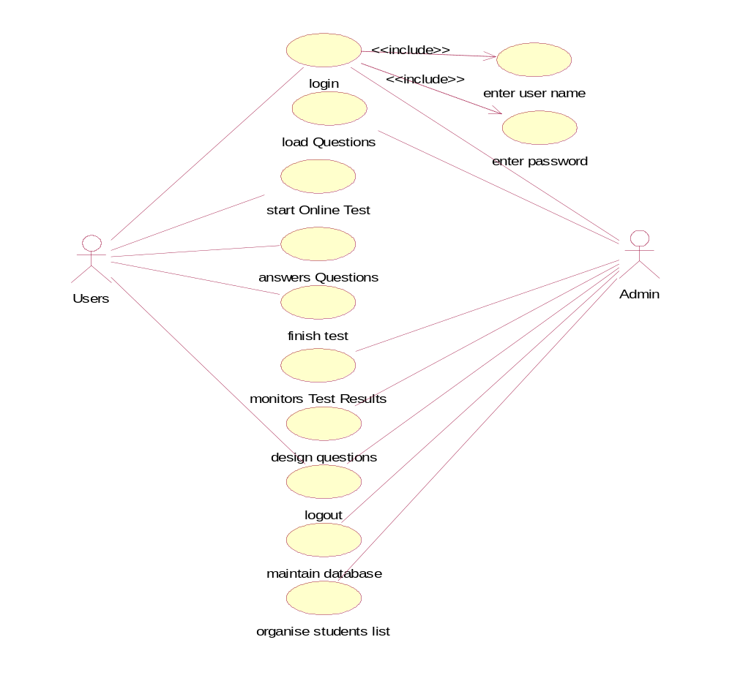

3.4.2 Use -case Diagram for User (student)

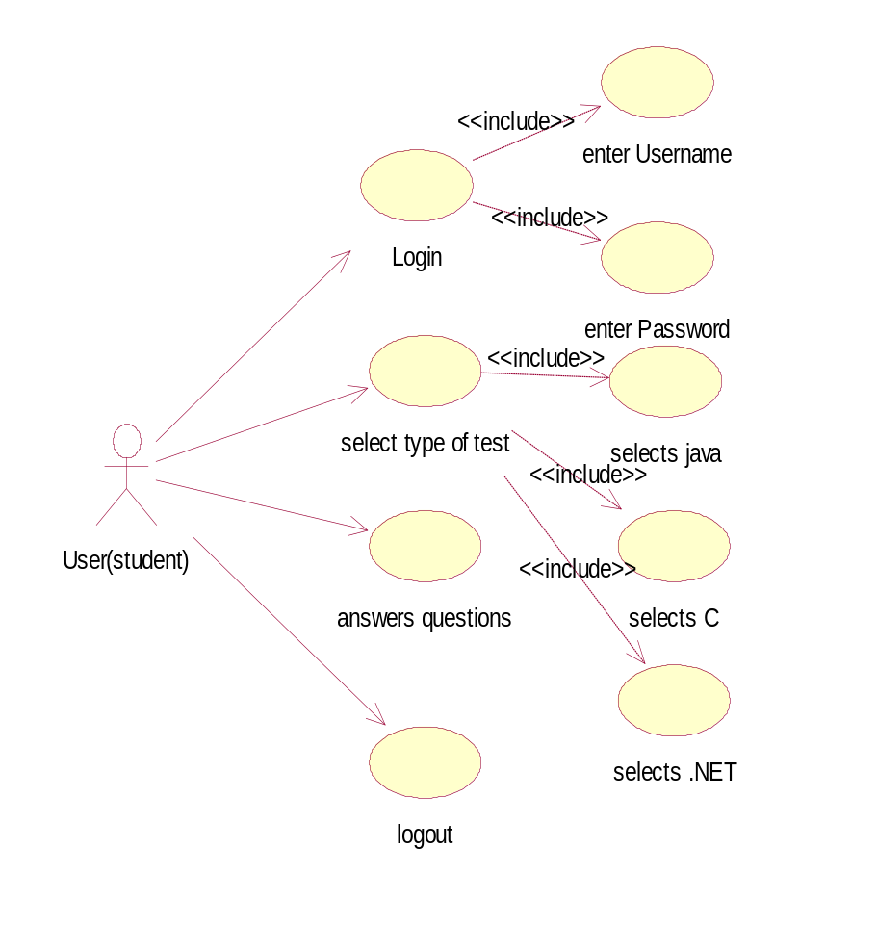

3.4.3 Use -case Diagram for Admin

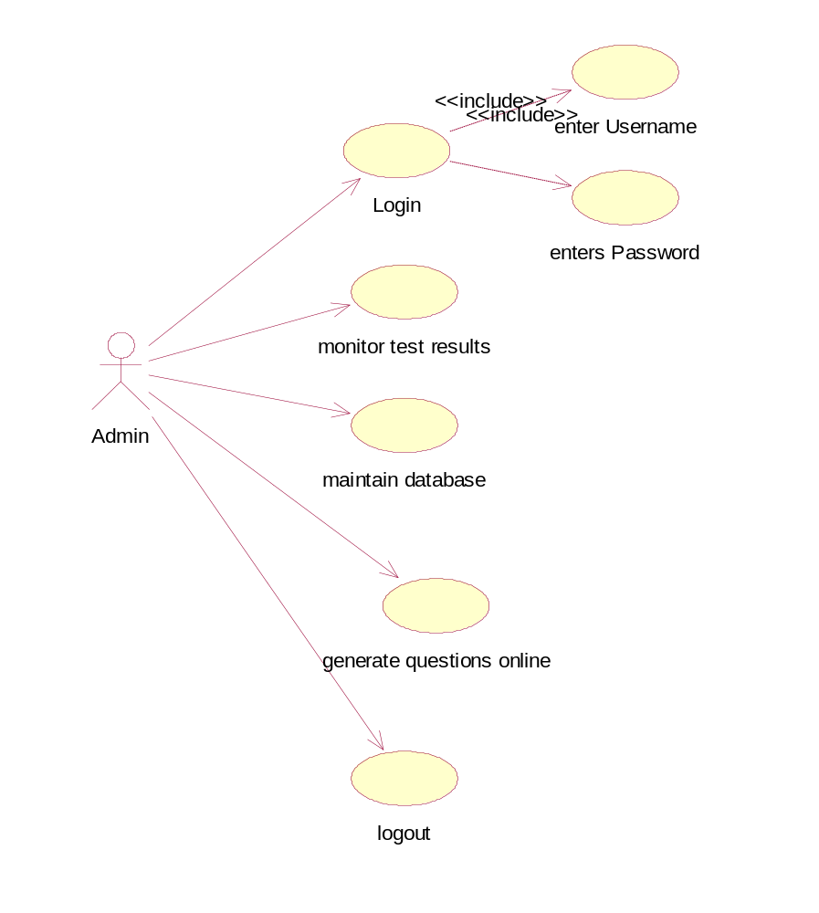

3.4.4 Class diagram
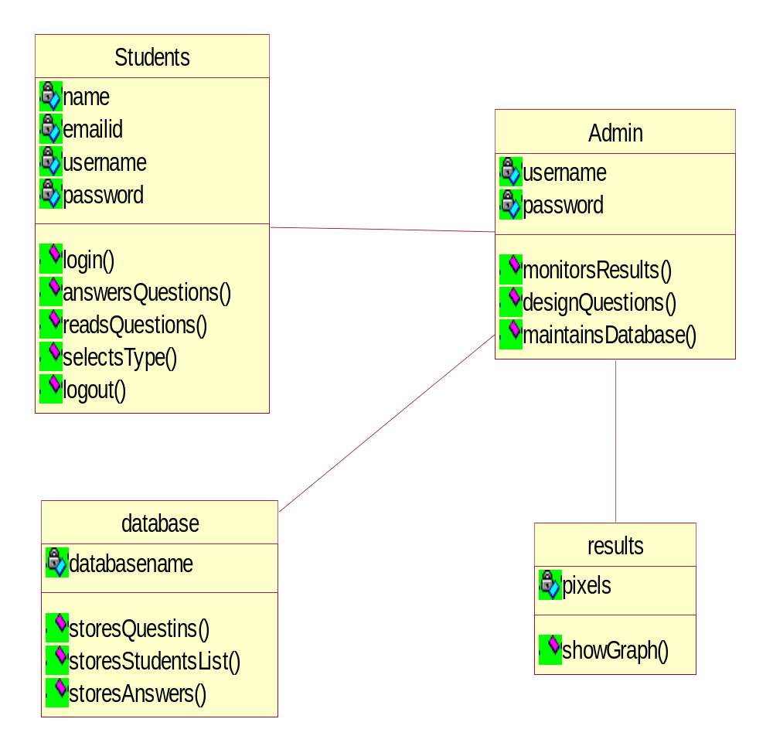

3.4.5 Sequence diagram for whole system

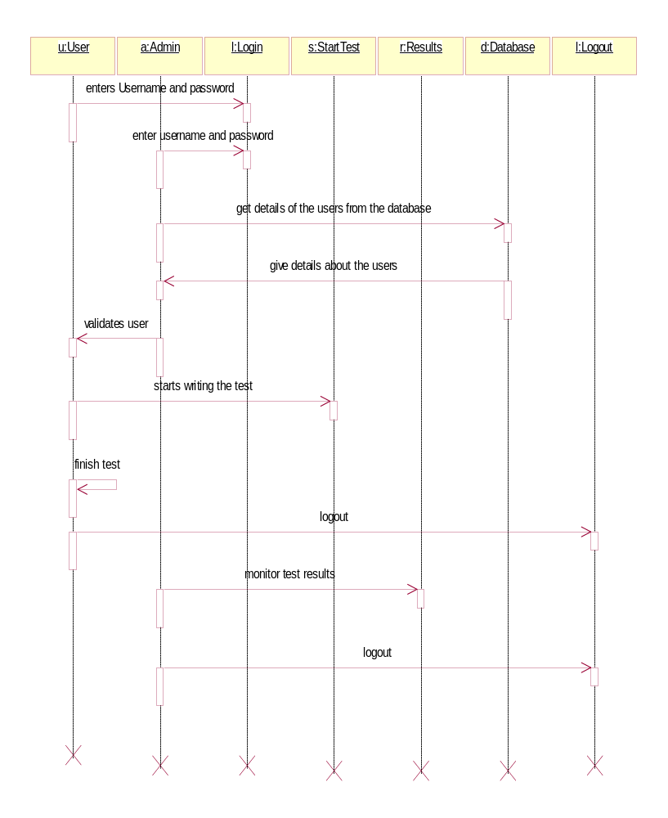

3.4.6 Collaboration Diagram for whole System
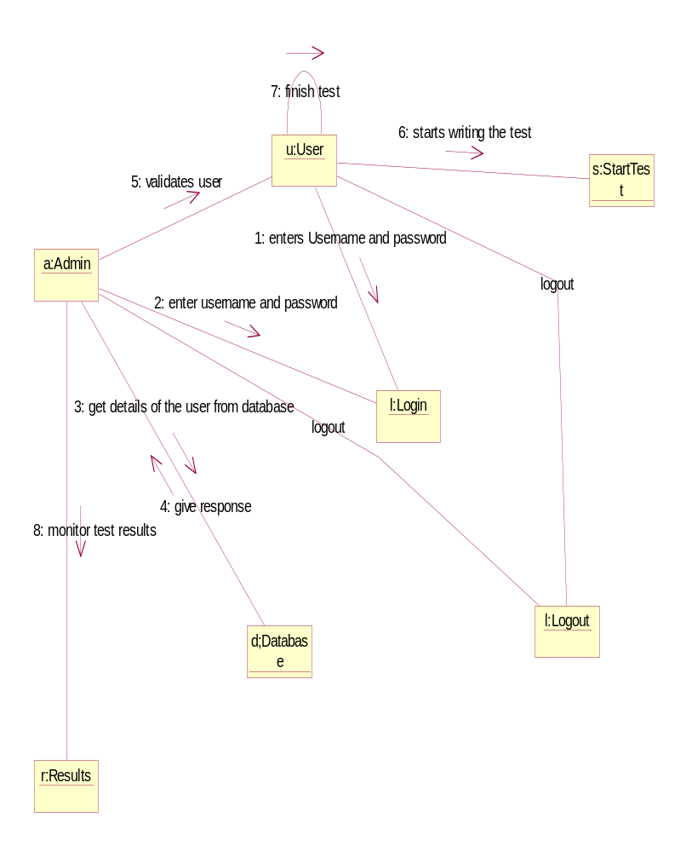

3.4.7 Activity diagram for Admin:

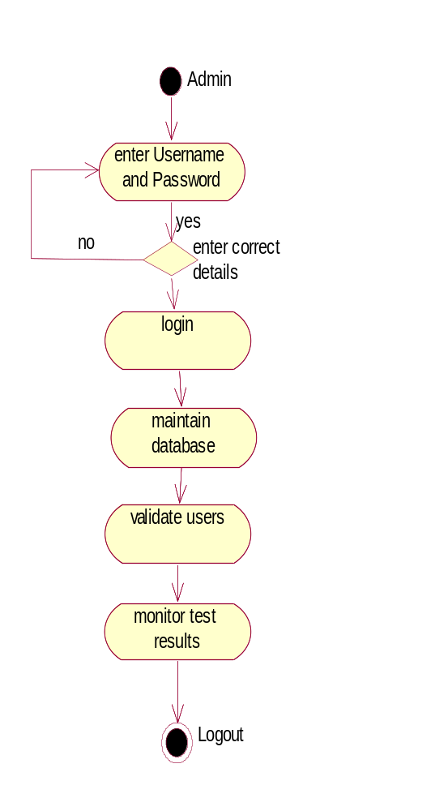

3.4.8 Activity diagram for User(student):
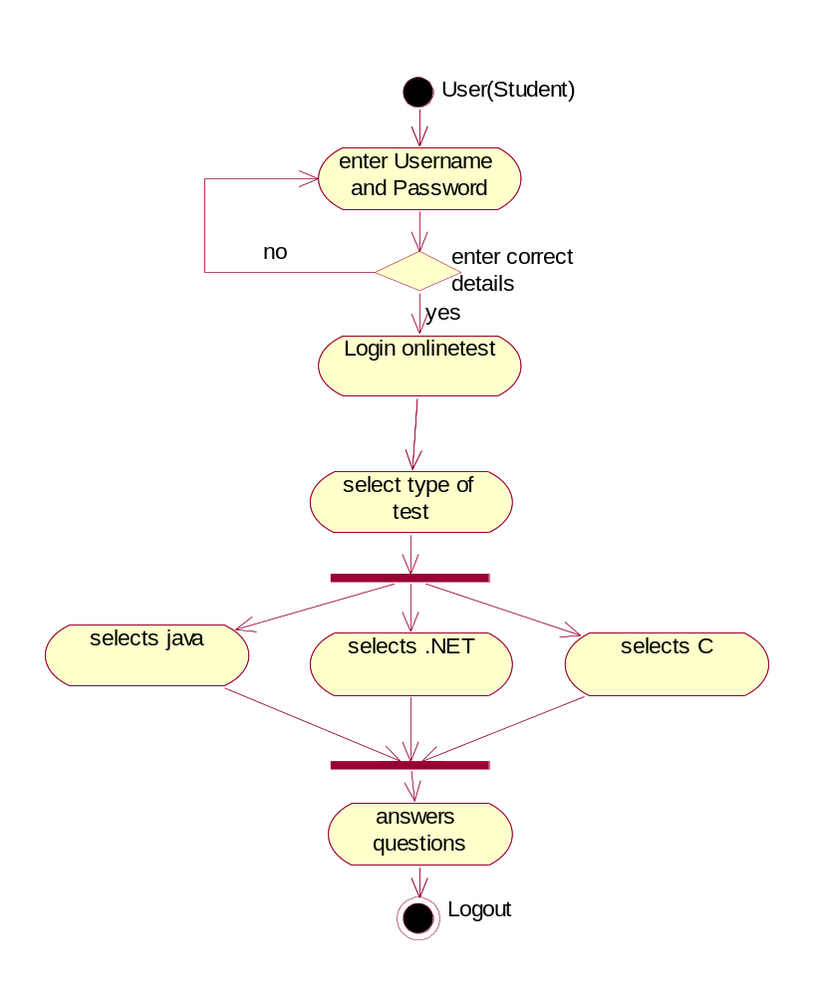

3.4.9 State chart diagram

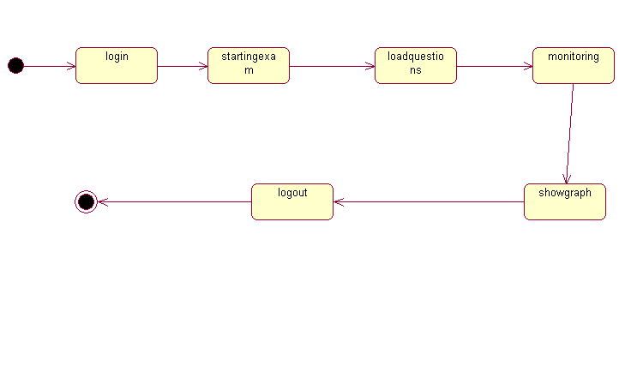

implementation

4.1 Modules in my project
- Online Test Management
- Data Visualization

4.2 modules description
4.2.1 Online Test Management
This module contains framing of questions related to online tests like java, . NET etc., The students are required to register for writing an online test. After login, he need to choose the test he wants to write. After choosing the required test, a no of questions will be given with a set of options. The students need to select answers from those options.
4.2.3 Data Visualization
As opposed to textual or verbal communication of information, data visualization provides a graphical representation of data, documents, and structures, which turns out to be
useful for various purposes.
- Data visualization provides an overview of complex and large data sets, shows a summary of the data, and helps humans in the identification of possible patterns and structures in the data. Thus, the goal of data visualization is to simplify the representation of a given data set, minimizing the loss of information .
- Visualization methods can be either geometric or symbolic. In a geometric visualization, data are represented by using lines, surfaces, or volumes and are usually obtained from a physical model or as a result of a simulation or a generic computation. Symbolic visualization represents non-numeric data using pixels, icons, arrays, or graphs.
In this module, the administrator will monitor the online test results through Data Visualization by means of graphs.

4.3 technology used in this project
Java has two things: a programming language and a platform. Java is a high-level programming language that is all of the following :

Simple, Architecture-neutral, Object-oriented, Portable, Secure, Distributed , High performance, Interpreted, Multithreaded, Robust, Dynamic programming language.

Java is also unusual in that each Java program is both compiled and interpreted. With a compile you translate a Java program into an intermediate language called Java byte codes the platform-independent code instruction is passed and run on the computer.

You can think of Java byte codes as the machine code instructions for the Java Virtual Machine (Java VM). Every Java interpreter, whether it’s a Java development tool or a Web browser that can run Java applets, is an implementation of the Java VM. The Java VM can also be implemented in hardware.
Java byte codes help make “write once, run anywhere” possible. You can compile your Java program into byte codes on my platform that has a Java compiler. The byte codes can then be run any implementation of the Java VM. For example, the same Java program can run Windows NT, Solaris, and Macintosh.

4.3.1 Java Platform
A platform is the hardware of software environment in which a program runs. The Java platform differs from most other platforms in that it’s a software only platform that runs on the top of other, hardware-based platform. Most other platforms are described as a combination of hardware and operating system.
The Java platform has two components:
- The Java Virtual Machine (JVM)
- The Java Application Programming Interface (Java API)
You’ve already been introduced to the Java VM. It’s the base for the Java platform and is ported onto various hardware-based platforms.
The Java API is a large collection of ready-made software components that provide many useful capabilities, such as graphical user interface (GUI) widgets.
The Java API is grouped into libraries (package) of related components. The next sections, what can Java do? Highlights each area of functionally provided by the package in the Java API.
How does the Java API support all of these kinds of programs? With packages of software components that provide a wide range of functionality. The API is the API included in every full implementation of the platform.
Worldwide programs can automatically adapt to specific locates and be displayed in the appropriate language
4.3.2 Apache Struts
Apache Struts is a free open-source framework for creating Java web applications.
Web applications differ from conventional websites in that web applications can create a dynamic response. Many websites deliver only static pages. A web application can interact with databases and business logic engines to customize a response.
Web applications based on Java Server Pages sometimes commingle database code, page design code, and control flow code. In practice, we find that unless these concerns are separated, larger applications become difficult to maintain.
One way to separate concerns in a software application is to use a Model-View-Controller (MVC) architecture. The Model represents the business or database code, the View represents the page design code, and the Controller represents the navigational code. The Struts framework is designed to help developers create web applications that utilize a MVC architecture.
The framework provides three key components:
A "request" handler provided by the application developer that is mapped to a standard URI.
A "response" handler that transfers control to another resource which completes the response.
A tag library that helps developers create interactive form-based applications with server pages. The framework's architecture and tags are buzzword compliant. Struts works well with conventional REST applications and with nouveau technologies like SOAP and AJAX.

4.3.3 Hibernate
Object/relational mapping framework for Java.
● Licensed under the Lesser GPL.
– Can be used in commercial products.
● Build persistent objects following common Java
idioms:
– Association
– Inheritance
– Polymorphism
– Composition
A major portion of the development of an enterprise application involves the creation and maintenance of the persistence layer used to store and retrieve objects from the database of choice. Many organizations resort to creating home grown, often buggy, persistence layers. If changes are made to the underlying database schema, it can be expensive to propagate those changes to the rest of the application. Hibernate steps in to fill this gap, providing an easy-to-use and powerful object-relational persistence framework for Java applications.
Hibernate provides support for collections and object relations, as well as composite types. In addition to persisting objects, Hibernate provides a rich query language to retrieve objects from the database, as well as an efficient caching layer and Java Management Extensions (JMX) support. User-defined data types and dynamic beans are also support.
Hibernate is released under the Lesser GNU Public License, which is sufficient for use in commercial as well as open source applications. It supports numerous databases, including Oracle and DB2, as well as popular open source databases such as SQL and My SQL. An active user community helps to provide support and tools to extend Hibernate and make using it easier.

How Hibernate Works
Rather than utilize byte code processing or code generation, Hibernate uses runtime reflection to determine the persistent properties of a class. The objects to be persisted are defined in a mapping document, which serves to describe the persistent fields and associations, as well as any subclasses or proxies of the persistent object. The mapping documents are compiled at application startup time and provide the framework with necessary information for a class.
Additionally, they are used in support operations, such as generating the database schema or creating stub Java source files.
A SessionFactory is created from the compiled collection of mapping documents.
The SessionFactory provides the mechanism for managing persistent classes, the Session interface. The Session class provides the interface between the persistent data store and the application. The Session interface wraps a JDBC connection, which can be user-managed or controlled by Hibernate, and is only intended to be used by a single application thread, then
closed and discarded.
Hibernate Properties
The properties that Hibernate uses to connect to the database and generate the schema are stored in a file called hibernate properties. For our purposes, this file only has five properties,
Hibernate Query Language
Queries written in HQL are essentially as powerful as their SQL counterparts. Inner and outer joins are supported, as are various functions such as avg(…), sum(…), min(…),and count(…). HQL also supports many other SQL-like functions and operations such as distinct and like. Sub queries are also supported if supported by the underlying database, as is the group by clause.
Named parameters allow you to specify names in the HQL statements instead of question marks as parameter flags. For example: select team.id from team in class example.Team where team.name=:name

To set the value of the :name parameter, use the Query.setParameter(…) method.
For the aforementioned statement, it would look like:
query.setParameter(“name”, “Pistons”, Hibernate.STRING);

HQL is a very rich object query language and, because of its depth, will be the subject
of a future article.

4.3.4 MySQL
MySQL is a relational database management system (RDBMS) that runs as a server providing multi-user access to a number of databases. It is named for original developer Michael Widenius's daughter My. The development project has made its source code available under the terms of the GNU General Public License, as well as under a variety of proprietary agreements. MySQL is owned and sponsored by a single for-profit firm, the Swedish company MySQL AB, now owned by Sun Microsystems, a subsidiary of Oracle Corporation.
Members of the MySQL community have created several forks such as Drizzle, OurDelta, Percona Server, and MariaDB. All of these forks were in progress before the Oracle acquisition (Drizzle was announced 8 months before the Sun acquisition).
Free-software projects that require a full-featured database management system often use MySQL. Such projects include (for example) WordPress, phpBB, Drupal and other software built on the LAMP software stack. MySQL is also used in many high-profile, large-scale World Wide Web products including Wikipedia, Google and Facebook.
Uses
The "M" in the acronym of the popular LAMP software stack refers to MySQL. Its popularity for use with web applications is closely tied to the popularity of PHP (the "P" in LAMP). Several of the highest-traffic web sites (including Flickr, Facebook, Wikipedia, Google (though not for searches), Nokia and YouTube) use MySQL for data storage and logging of user data.

Platforms and interfaces
MySQL code uses C and C++. The SQL parser uses yacc and a home-brewed lexer, sql_lex.cc
MySQL works on many different system platforms, including AIX, BSDi, FreeBSD, HP-UX, i5/OS, Linux, Mac OS X, NetBSD, Novell NetWare, OpenBSD, OpenSolaris, eComStation, OS/2 Warp, QNX, IRIX, Solaris, Symbian, SunOS, SCO OpenServer, SCO UnixWare, Sanos, Tru64 and Microsoft Windows. A port of MySQL to OpenVMS also exists.
Many programming languages with language-specific APIs include libraries for accessing MySQL databases. In addition, an ODBC interface called MyODBC allows additional programming languages that support the ODBC interface to communicate with a MySQL database, such as ASP or ColdFusion. The HTSQL - URL based query method also ships with MySQL adapter allowing direct interaction with MySQL database from any web client via structured URLs. The MySQL server and official libraries are mostly implemented in ANSI C/ANSI C++.
MySQL Workbench in Windows, displaying the Home Screen which streamlines use of its full capabilities.
MySQL is primarily an RDBMS and therefore ships with no GUI tools to administer MySQL databases or manage data contained within. Users may use the included command-line tools, download MySQL frontends from various parties that have developed desktop software and web applications to manage MySQL databases, build database structure, and work with data records.

  - Sample Code

double ctime = System.currentTimeMillis();
Session session = HibernateSessionFactory.getSession();
Criteria criteria = session.createCriteria(Ques.class);
Ques ques = new Ques();
request.getSession().setAttribute("time", new Integer(10));
Calendar calendar = Calendar.getInstance();
Date date = calendar.getTime();
TimeZone tz = TimeZone.getTimeZone("ECT");
SimpleDateFormat formatter = (SimpleDateFormat) DateFormat
.getDateTimeInstance(DateFormat.LONG, DateFormat.LONG,
Locale.US);

formatter.setTimeZone(tz);
formatter.applyPattern("yyyy-mm-dd hh:mm:ss");
String result = formatter.format(date);
request.getSession().setAttribute("ptime", result);
ques.setCategory(cat);
Criterion criterion = Example.create(ques);
criteria.add(criterion);
List list = criteria.list();
hsession.setAttribute("ques", list);
hsession.setAttribute("ctime", Double.valueOf(ctime));

Ques ques2 = (Ques) list.get(0);
request.setAttribute("eques", ques2);
hsession.setAttribute("qc", new Integer(0));
ans = ques2.getAns();
hsession.setAttribute("ans", ans);
if ("Next".equals(action))
{
Calendar calendar = Calendar.getInstance();
Date date = calendar.getTime();
TimeZone tz = TimeZone.getTimeZone("ECT");
SimpleDateFormat formatter = (SimpleDateFormat) DateFormat

long ti = DateDiff.getMin(ptime, ctime);
System.out.println(ti);
Integer cti = (Integer) request.getSession().getAttribute(
"time");
if (cti.intValue() < 0)
{
request.getSession().setAttribute("tstatus", "Time Out");
response.sendRedirect("sexam.do?action=Finish");
}
int a = cti.intValue() - (int) ti;
equest.getSession().setAttribute("time", new Integer(a));
String ty = precnt.get(qc);
if (uans==null||!uans.equals(ty))
{
Vector<String> temp = new Vector<String>();
temp.add("" + qc);
if (uans == null)
temp.add("null");
else
temp.add(uans);
map.add(temp);
fans.put(Integer.valueOf(qc), (String) hsession.getAttribute("ans"));
double ntime = System.currentTimeMillis();
double ct = ((Double) hsession.getAttribute("ctime"))
.doubleValue();
double tott = ntime - ct;
time.add(Double.valueOf(tott));
hsession.setAttribute("ctime", Double.valueOf(ntime));
}
precnt.put(Integer.valueOf(qc), uans);
List list = (List) hsession.getAttribute("ques");
}
if ("Previous".equals(action))
{
Integer cti = (Integer) request.getSession().getAttribute(
"time");
String ty = precnt.get(qc);
precnt.put(Integer.valueOf(qc), uans);
if (cti.intValue() < 0) {
request.getSession().setAttribute("tstatus", "Time Out");
response.sendRedirect("sexam.do?action=Finish");
}
if (qc >= 1)
{
List list = (List) hsession.getAttribute("ques");
--qc;
Ques ques = (Ques) list.get(qc);
request.setAttribute("eques", ques);
hsession.setAttribute("qc", Integer.valueOf(qc));
hsession.setAttribute("hint", "");
hsession.setAttribute("ans", ques.getAns());
}
else
{
List list = (List) hsession.getAttribute("ques");
Ques ques = (Ques) list.get(0);
Vector t = (Vector) map.get(0);
String lans = (String) t.get(1);
request.setAttribute("eques", ques);
hsession.setAttribute("qc", Integer.valueOf(qc));
hsession.setAttribute("hint", "");
hsession.setAttribute("ans", ques.getAns());
}
}
if ("Hint".equals(action))
{
List list = (List) hsession.getAttribute("ques");
Ques ques = (Ques) list.get(qc);
Vector<Integer> h = (Vector<Integer>) request.getSession()
.getAttribute("thint");
h.add(new Integer(qc));
request.getSession().setAttribute("thint", h);
request.setAttribute("eques", ques);
hsession.setAttribute("hint", ques.getHint());
}
if ("Finish".equals(action))
{
Vector<String> temp = new Vector<String>();

Vector<Vector<Integer>> vv = new Vector<Vector<Integer>>();
temp.add("" + qc);
if (uans == null)
temp.add("null");
else
temp.add(uans);
map.add(temp);
precnt.put(Integer.valueOf(qc), uans);
fans.put(Integer.valueOf(qc), (String) hsession
.getAttribute("ans"));
double ntime = System.currentTimeMillis();
double ct = ((Double) hsession.getAttribute("ctime"))
.doubleValue();
double tott = ntime - ct;
time.add(Double.valueOf(tott));
Vector<Double> fvec = new Vector<Double>();
Double ll = Double.valueOf(0.0D);
fvec.add(ll);
for (int i = 0; i < time.size(); ++i)
{
Double tm = (Double) time.get(i);
tm = Double.valueOf(tm.doubleValue() / 1000.0D);
ll = Double.valueOf(ll.doubleValue() + tm.doubleValue());
fvec.add(ll);
}
Set<Integer> faset = fres.keySet();
Iterator<Integer> iitt = faset.iterator();
while (iitt.hasNext()) {
Integer type = (Integer) iitt.next();
String str = (String) fres.get(type);
if (str.equals("N"))
nna.add(Integer.valueOf(type.intValue() + 1));
else if (str.equals("C"))
cca.add(Integer.valueOf(type.intValue() + 1));
else
{
wwa.add(Integer.valueOf(type.intValue() + 1));
}
}
XYDataset dataset = createDataset(map, fvec);
createChart(dataset, (String) hsession.getAttribute("uname"));
Session hSession = HibernateSessionFactory.getSession();
TestUser user = new TestUser();
String uname = (String) hsession.getAttribute("uname");
Date date = new Date();
Calendar calendar = Calendar.getInstance();
uname = uname + "_" + date.getDate() + "-"
+ ((date.getMonth()) + 1) + "-"
+ calendar.get(Calendar.YEAR);

user.setUser(uname);
Transaction ts = hSession.beginTransaction();
hSession.save(user);
ts.commit();
vv.add(cca);
vv.add(wwa);
vv.add(nna);
vv.add(hh);
File file = new File("c:/results/");
file.mkdir();
File file2 = new File("c:/results/" + uname + ".txt");
file2.createNewFile();
FileOutputStream fos = new FileOutputStream(file2);
ObjectOutputStream oos = new ObjectOutputStream(fos);
oos.writeObject(vv);
oos.close();

return mapping.findForward("finish");
}
String lans = (String) precnt.get(Integer.valueOf(qc));
System.out.println("lans:" + lans);
if (lans != null)
{
request.setAttribute("lans", lans);
}
}
return mapping.findForward("exam");
}
private XYDataset createDataset(Vector<Vector<String>> map,
Vector<Double> fvec) {
XYSeries series1 = new XYSeries("Answered");
Vector qv = new Vector();
Vector av = new Vector();
for (int i = 0; i < map.size() - 1; ++i)
{
Vector t = (Vector) map.get(i);
double qn = Double.parseDouble((String) t.get(0)) + 1.0D;
double tm = ((Double) fvec.get(i)).doubleValue();
String ans = (String) t.get(1);
if (!ans.equals("null"))
{
if (qv.contains(Double.valueOf(qn))) {
for (int j = 0; j < qv.size(); ++j) {
if ((qn != ((Double) qv.get(j)).doubleValue())|| (ans.equals(av.get(j))))
continue;
series1.add(tm, qn);
}
}
else {
series1.add(tm, qn);
qv.add(Double.valueOf(qn));
av.add(ans);
}
}
}
XYSeries series2 = new XYSeries("Time Duration");
for (int i = 0; i < map.size() - 1; ++i)
{
Vector t = (Vector) map.get(i);
double qn = Double.parseDouble((String) t.get(0)) + 1.0D;
double tm = ((Double) fvec.get(i)).doubleValue();
series2.add(tm, qn);
}
XYSeriesCollection dataset = new XYSeriesCollection();
dataset.addSeries(series1);
dataset.addSeries(series2);
return dataset;
}

private String createChart(XYDataset dataset, String uname)
{
JFreeChart chart = ChartFactory.createXYLineChart("Data Visualization",
"Time", "Questions", dataset, PlotOrientation.VERTICAL, true,
true, false);
chart.setBackgroundPaint(Color.white);
XYPlot plot = chart.getXYPlot();
plot.setBackgroundPaint(Color.lightGray);
plot.setDomainGridlinePaint(Color.white);
plot.setRangeGridlinePaint(Color.white);
XYLineAndShapeRenderer renderer = new XYLineAndShapeRenderer();
renderer.setSeriesLinesVisible(0, false);
renderer.setSeriesShapesVisible(1, false);
plot.setRenderer(renderer);
NumberAxis rangeAxis = (NumberAxis) plot.getRangeAxis();
rangeAxis.setStandardTickUnits(NumberAxis.createIntegerTickUnits());
try {
File file = new File("c:/graphs/");
file.mkdirs();
} catch (Exception e) {
e.printStackTrace();
}
Date date = new Date();
Calendar calendar = Calendar.getInstance();
uname = uname + "_" + date.getDate() + "-" + ((date.getMonth()) + 1)
+ "-" + calendar.get(Calendar.YEAR);
Try
{
ChartRenderingInfo info = new ChartRenderingInfo(
new StandardEntityCollection());
File file1 = new File(filename);
ChartUtilities.saveChartAsPNG(file1, chart, 600, 400, info);
}
catch (Exception e)
{
e.printStackTrace();
}
return filename;
}
}
class DateDiff
{
static SimpleDateFormat df = new SimpleDateFormat("yyyy-mm-dd hh:mm:ss");
private String sD1;
private String sD2;
public DateDiff(String sD1, String sD2)
{
this.sD1 = sD1;
this.sD2 = sD2;
}
public long getDifferenceInMinutes() throws ParseException {
Date d1 = df.parse(sD1);
Date d2 = df.parse(sD2);
long d1Ms = d1.getTime();
long d2Ms = d2.getTime();
return Math.abs((d1Ms - d2Ms) / 60000);
}
public static long getMin(String ptime, String ctime)
{
DateDiff dd = new DateDiff(ptime, ctime);
long diff = 0;
try
{
diff = dd.getDifferenceInMinutes();
}
catch (ParseException ex)
{
ex.printStackTrace();
}
return diff;
}
}

Testing

5.1 Testing
Software Testing is a critical element of software quality assurance and represents the ultimate review of specification, design and coding, Testing presents an interesting anomaly for the software engineer.
5.1.1 Testing Objectives include
- Testing is a process of executing a program with the intent of finding an error
- A good test case is one that has a probability of finding an as yet undiscovered error
- A successful test is one that uncovers an undiscovered error
5.1.2 Testing Principles
- All tests should be traceable to end user requirements
- Tests should be planned long before testing begins
- Testing should begin on a small scale and progress towards testing in large
- Exhaustive testing is not possible
- To be most effective testing should be conducted by a independent third party
5.1.3 Testing Strategy
A Strategy for software testing integrates software test cases into a series of well planned steps that result in the successful construction of software. Software testing is a broader topic for what is referred to as Verification and Validation. Verification refers to the set of activities that ensure that the software correctly implements a specific function. Validation refers he set of activities that ensure that the software that has been built is traceable to customer’s requirements
Unit Testing
Unit testing focuses verification effort on the smallest unit of software design that is the module. Using procedural design description as a guide, important control paths are tested to uncover errors within the boundaries of the module. The unit test is normally white box testing oriented and the step can be conducted in parallel for multiple modules.
Integration Testing
Integration testing is a systematic technique for constructing the program structure, while conducting test to uncover errors associated with the interface. The objective is to take unit tested methods and build a program structure that has been dictated by design.
Top-down Integration
Top down integrations is an incremental approach for construction of program structure. Modules are integrated by moving downward through the control hierarchy, beginning with the main control program. Modules subordinate to the main program are incorporated in the structure either in the breath-first or depth-first manner.
Bottom-up Integration
This method as the name suggests, begins construction and testing with atomic modules i.e., modules at the lowest level. Because the modules are integrated in the bottom up manner the processing required for the modules subordinate to a given level is always available and the need for stubs is eliminated.
Validation Testing
At the end of integration testing software is completely assembled as a package. Validation testing is the next stage, which can be defined as successful when the software functions in the manner reasonably expected by the customer. Reasonable expectations are those defined in the software requirements specifications. Information contained in those sections form a basis for validation testing approach.
System Testing
System testing is actually a series of different tests whose primary purpose is to fully exercise the computer-based system. Although each test has a different purpose, all work to verify that all system elements have been properly integrated to perform allocated functions.
Security Testing
Attempts to verify the protection mechanisms built into the system.
Performance Testing
This method is designed to test runtime performance of software within the context of an integrated system.

For testing purpose in this project we used :
- Unit testing
- Integration testing
- System testing
- Validation testing
- Security testing

5.2 TEST CASES
5.2.1 Test Case 1
Description | If student/admin click on login button without entering the username  and password fields
Expected value | Returns a error message enter user name and password
Actual value | Returns a error message enter user name and password
Result | Success

Testing on Login Button
5.2.2 Test Case 2
Description | If the student selects the required online test he wants to write.
Expected value | Returns questions related to the topic as chosen by the student(link)
Actual value | Returns questions related to the topic as chosen by the student
Result | Success

Testing on the link:topic chosen by students

5.2.3 Test case 3:
Description | If the students click on the finish button
Expected value | comes out of test with a thank you page
Actual value | Comes out of test with a thank you page
Result | Success
Testing on finish button

5.2.4 Test case 4:
Description | If the admin clicks on monitor test results link
Expected value | a graph is generated according to the questions attempted by the students
Actual value | a graph is generated according to the questions attempted by the students
Result | Success
Testing on monitor test results link

5.2.5 Test case 5:
Description | If the admin clicks on logout button
Expected value | returns from the online tests website
Actual value | returns from the online tests website
Result | Success
Testing on logout button

SCREEN SHOTS

5.3.1 User Login Screen:

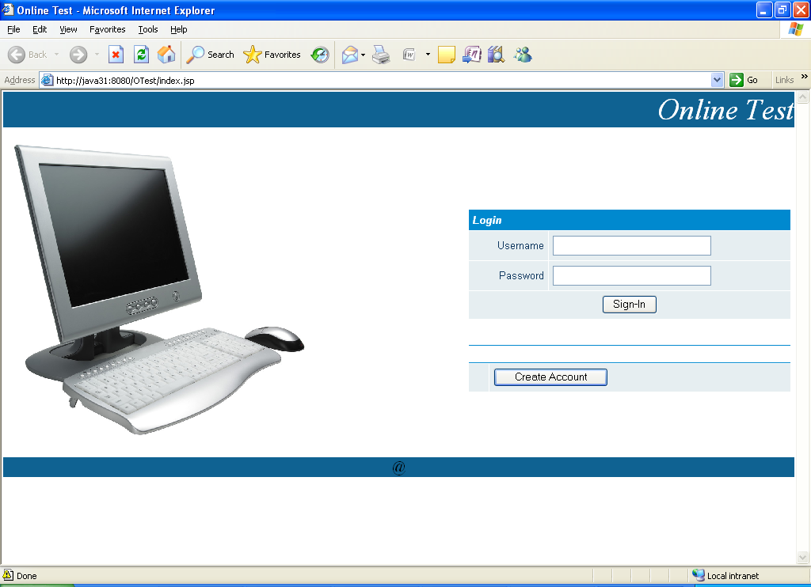

5.3.2 Sign Up Screen:

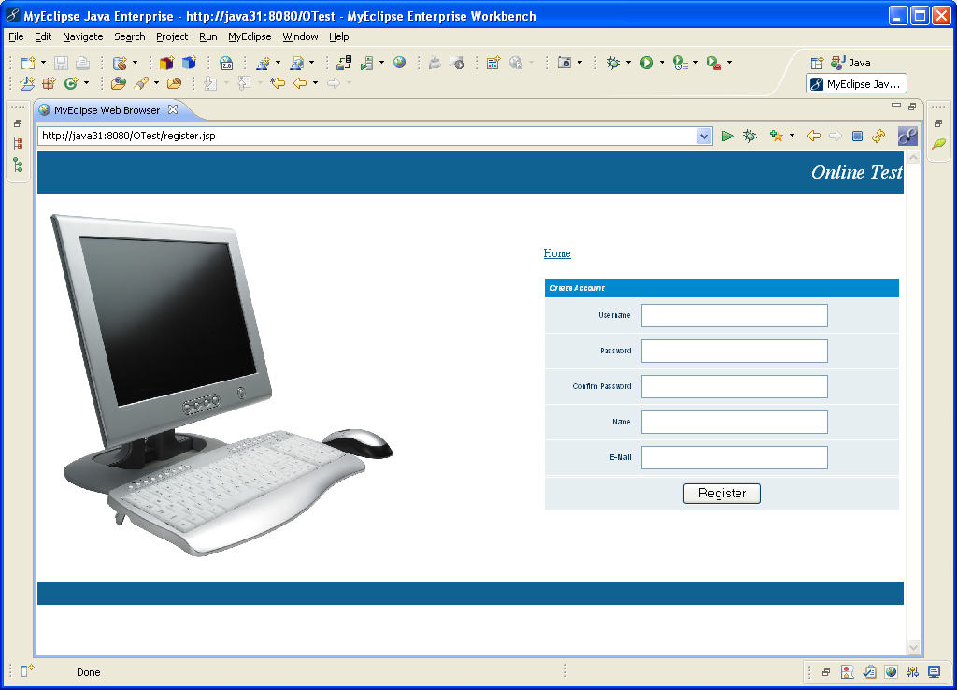

5.3.3 Admin Modules Screen:

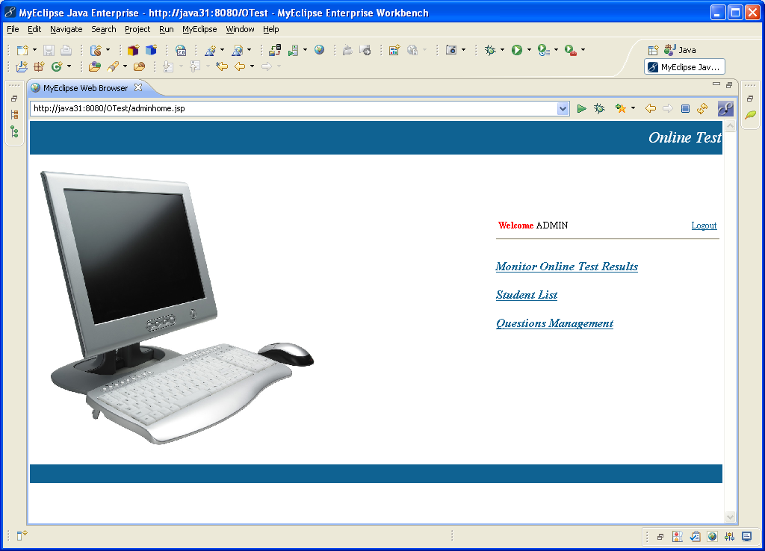

5.3.4 Students List:

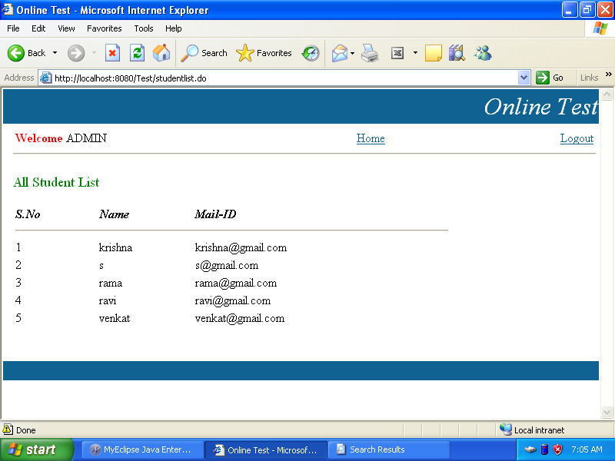

5.3.5 Question Management:

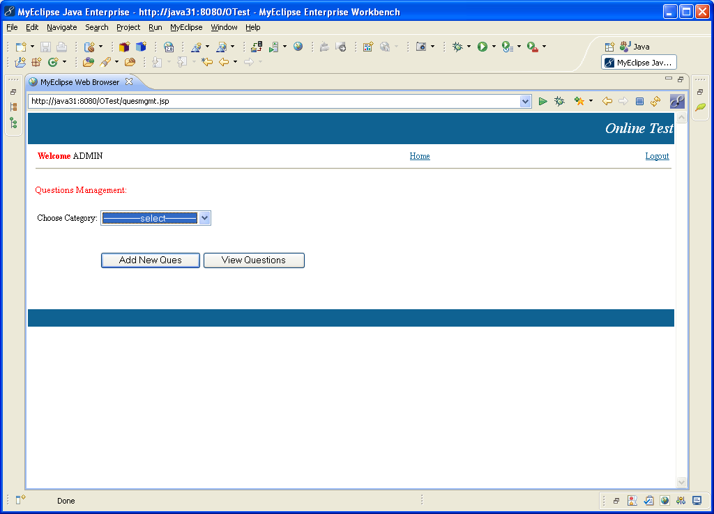

5.3.6 Online Test:

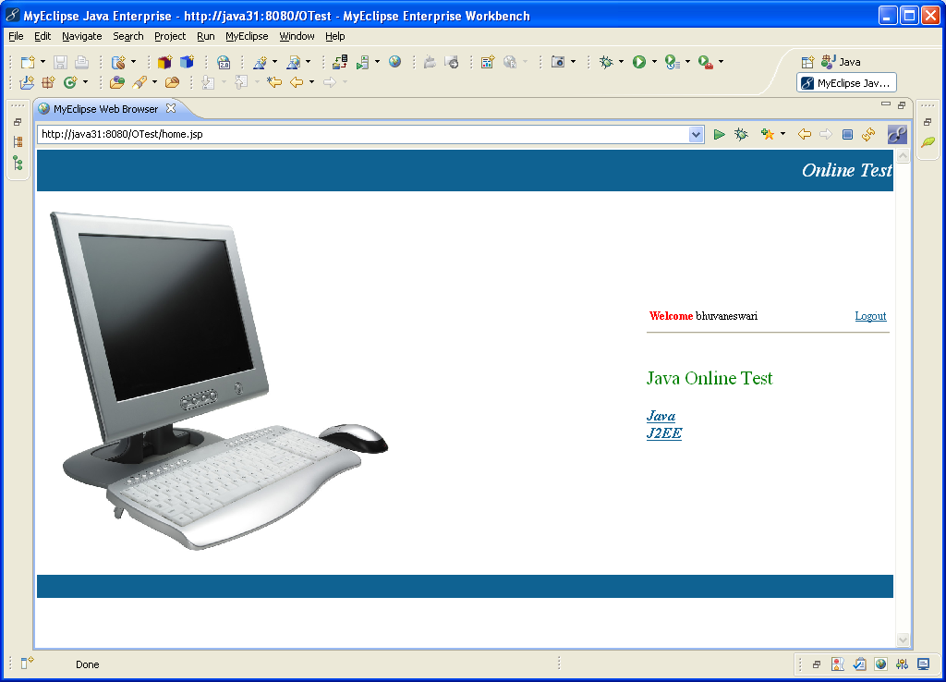

5.3.7 Answering Questions:

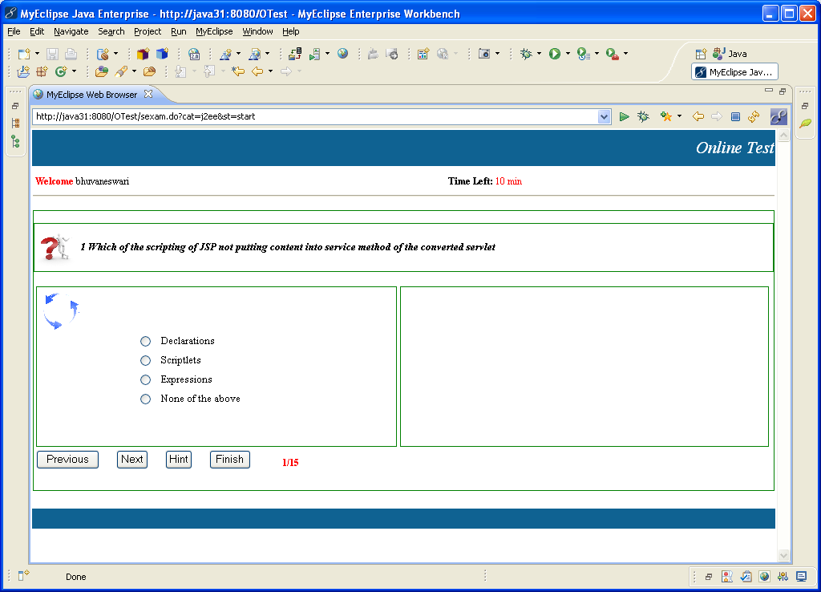

5.3.8 Logout Screen:

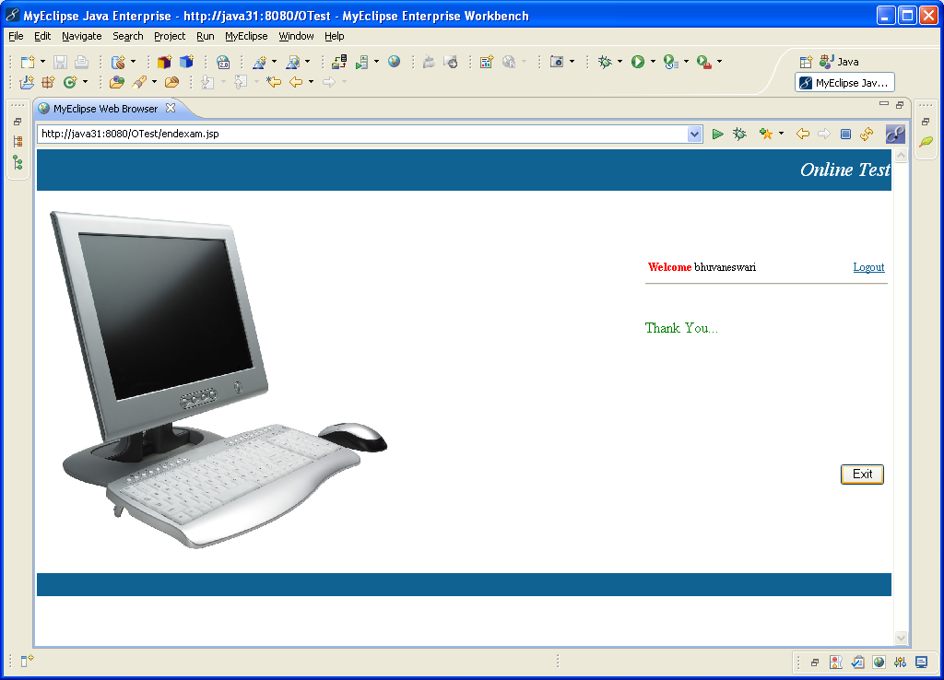

5.3.9 Data Visualization:

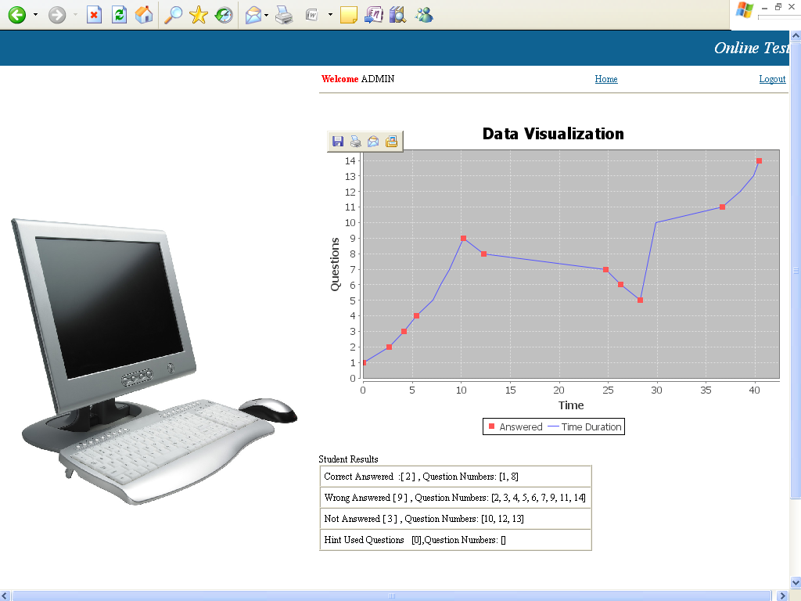

CONCLUSION

6. CONCLUSION

I have presented this project about a system to let the students to write technical related online tests and to let the tutors monitor learners’ strategies during online tests. The approach exploits data visualization to draw the data characterizing the learner’s test strategy, in order to trigger the tutor’s attention and to let him/her discover the strategy of the learners according to the questions attempted by the learners and the time to complete the test. In this way, the tutor is provided with a powerful tool that lets him/her review the whole assessment process and evaluate possible improvements. I have extensively used the implemented system experimentally to evaluate online test strategies in the courses of our faculty, in order to assess the whole approach.

8. BIBLIOGRAPHY

[1] J.B. Best, “Item Difficulty and Answer Changing,” Teaching of Psychology, vol. 6, no. 4, pp. 228-240, 1979.

[2] C.A. Paul and J.S. Rosenkoetter, “The Relationship between the Time Taken to Complete an Examination and the Test Score Received,” Teaching of Psychology, no. 7, pp. 108-109, 1980.

[3] U. Fayyad and G. Grinstein, “Introduction,” Information Visualisation in Data Mining and Knowledge Discovery, Morgan Kaufmann, 2002.

[4] G. Grinstein and M. Ward, “Introduction to Data Visualization,” Information Visualisation in Data Mining and Knowledge Discovery, Morgan Kaufmann, 2002.

[5] D.A. Keim, “Information Visualization and Visual Data Mining,” IEEE Trans. Visualization and Computer Graphics, vol. 8, no. 1, pp. 1-8, Jan.-Mar. 2002.

[6] Hibernate, Hibernate Framework, http://www.hibernate.org, 2007.

[7] M. Sasakura and S. Yamasaki, “A Framework for Adaptive E-Learning Systems in Higher Education with Information Visualization,” Proc. 11th Int’l Conf. Information Visualization
(IV ’07), pp. 819-824, 2007.

8.1 Web References
- www.google.com
- www.java2s.com
- www.roseindia.net
- www.wikipedia.org
- www.apachestruts.org

8.2 Book References
1. Edward Tufte's Data Visualisation and Information Design.
2. An introduction to Data Mining by Han Kamber, Prentice Hall of India Pvt. Ltd.
3. An introduction to MySQL by O’Reilly publishing House Pvt. Ltd.
4. An introduction to Struts and Hibernate by K.Santhosh Kumar, Black Book.
5. An introduction to Java by R. Nageswara Rao, DreamTech Publications Pvt. Ltd.,

